Advertising Vaccine Events Social Media Toolkit
Feel free to add your organization’s logo alongside the VacciNative logo on each social media post.

Post 1: Don’t miss out on fun times!❤️❤️❤️To help you stay healthy_____ [clinic] is offering ____ [insert type of vaccine] vaccines. So, stop by ____ [insert location] between ____ [insert times] Monday - Friday. Everyone will receive ____ [incentive]!

For accurate info about vaccines for Native adults: www.IndianCountryECHO.org/VacciNative

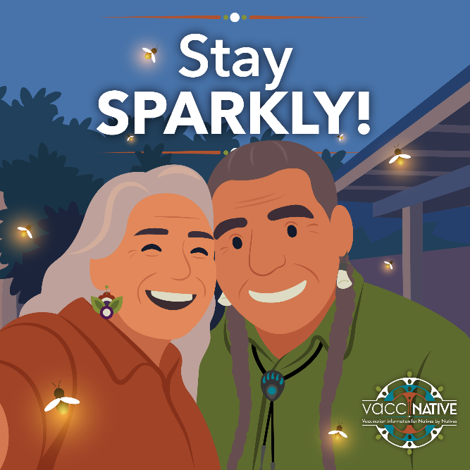
Instagram – Edit in Canva!

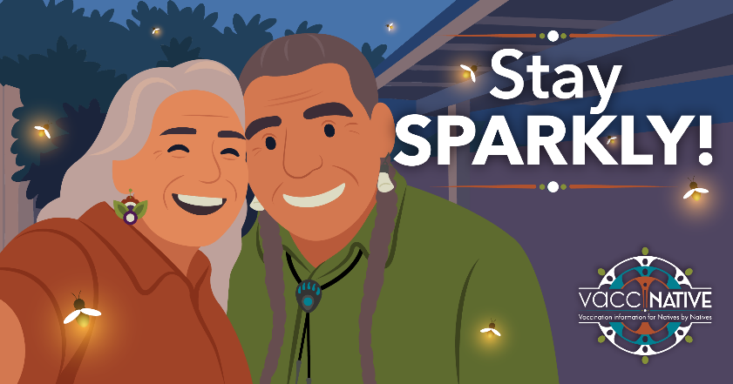
Facebook – Edit in Canva!

Post 2: Sickness can get in the way of doing what you love! Protect yourself. To help you stay healthy_____ [clinic] is offering ____ [insert type of vaccine] vaccines. So, stop by ____ [insert location] between ____ [insert times] Monday - Friday. Everyone will receive ____ [incentive]!
For accurate info about vaccines for Native adults: www.IndianCountryECHO.org/VacciNative

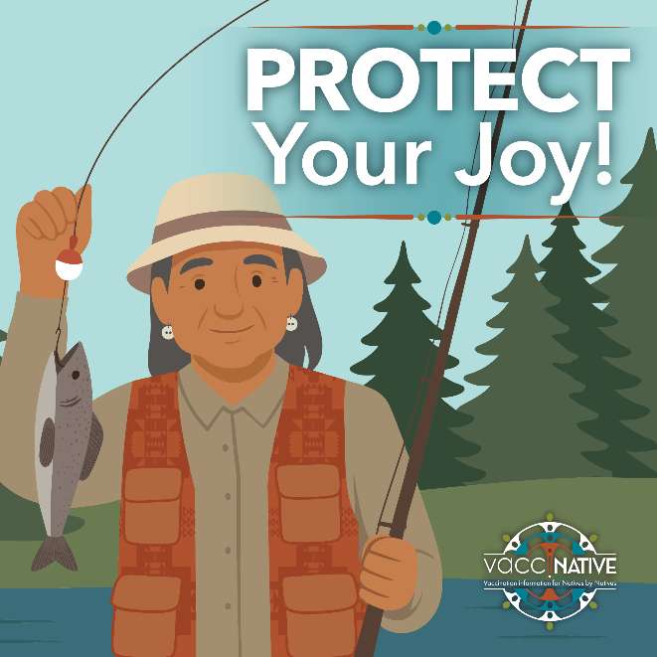
Instagram – Edit in Canva!

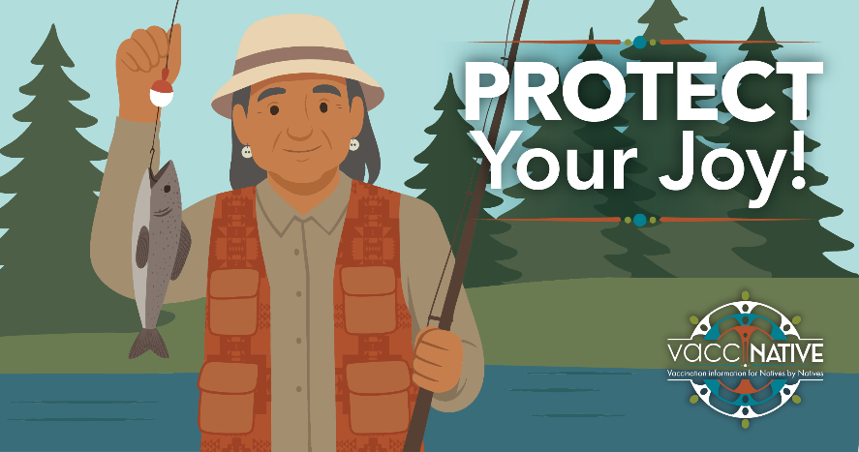
Facebook – Edit in Canva!

Post 3: Come together when it really matters. ❤️❤️❤️ To protect the community _____ [clinic] is offering ____ [insert type of vaccine] vaccines. So, stop by ____ [insert location] between ____ [insert times] Monday-Friday. Everyone will receive ____ [incentive]!

For accurate info about vaccines for Native adults: www.IndianCountryECHO.org/VacciNative

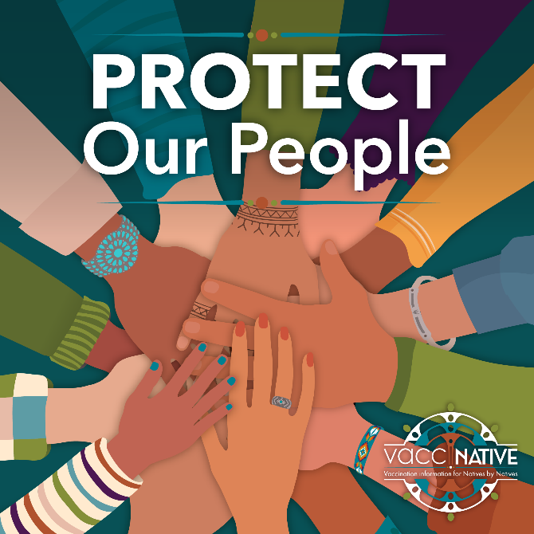
Instagram – Edit in Canva!


Facebook – Edit in Canva!

Post 4: Some things are written in the stars! _____ [location] is offering _____ [vaccine appointments]. Stop by ____ [insert location] between ____ [insert times] Monday - Friday. Everyone will receive ____ [incentive]!

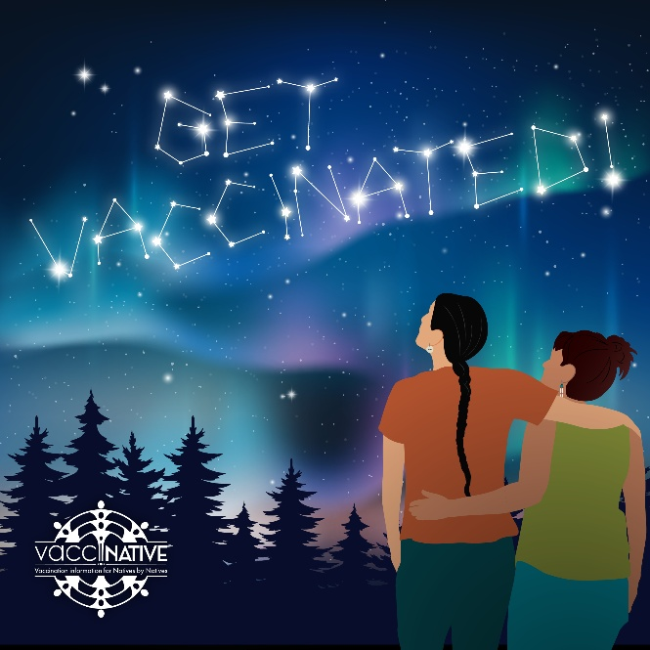
Instagram – Edit in Canva!

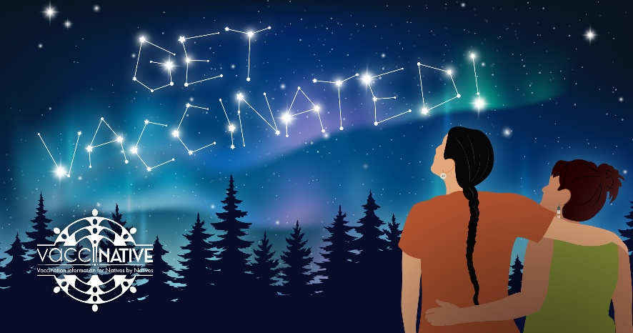
Facebook - Edit in Canva!

