Back to School Newsletter Template
Use this template to create an article for your tribal newsletter, newspaper, or magazine. Feel free to change the language and/or images to meet your needs!

Get Ready for a Great School Year

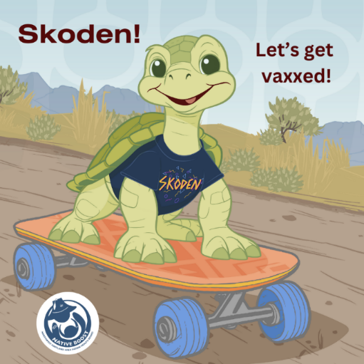
As the school year approaches and you are gathering backpacks, notebooks, and other supplies, don’t forget another essential part of preparing your kids for school – vaccinations.

Even healthy kids need vaccines! Vaccines teach our body’s warrior cells – or antibodies - how to recognize and fight certain serious diseases - like cancer, measles, and polio. Without this knowledge they can’t protect us.

Don’t let illness slow your child’s roll! Schedule a back-to-school wellness appointment. At the visit, talk to your child’s health provider to learn what vaccines they need.

When our kids are vaccinated according to the recommended vaccine schedule, it’s less likely that they will get sick. They are also less likely to spread illness to others who are more vulnerable - like Elders, young babies, and people with certain health conditions.

Teaching our kids to be good relatives is a lesson we can all share from home - even before they start the new school year! Skoden! Let’s make this school year a great one.

For accurate childhood vaccine information that’s fact checked by trusted Elders and Native health professionals, visit Native Boost’s website at: www.IndianCountryECHO.org/Boost.

Consider using these images to accompany your article:

