Native Boost Social Media Toolkit
Image 1:

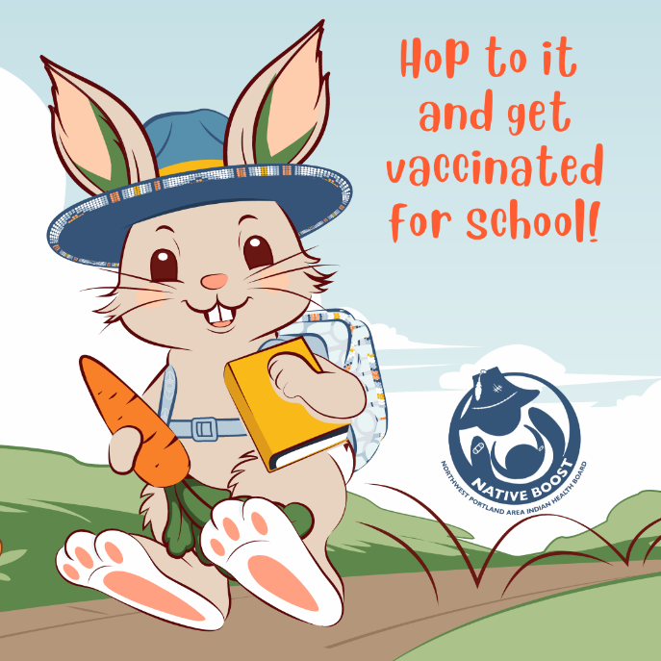

Proposed Text: Make sure your little one hops into school with their backpack and vaccines on point! 🐰✏️ Being up to date on vaccines contributes to academic success by reducing sick days and trips to the clinic. Learn more at: www.NPAIHB.org/Native-Boost. #HoppinIntoSchool #NativeBoost
Edit on Canva: https://www.canva.com/design/DAGiwNkjb5U/Ki7S0_9wWhY6OqmEnKwDzw/view?utm_content=DAGiwNkjb5U&utm_campaign=designshare&utm_medium=link&utm_source=publishsharelink&mode=preview

Image 2:
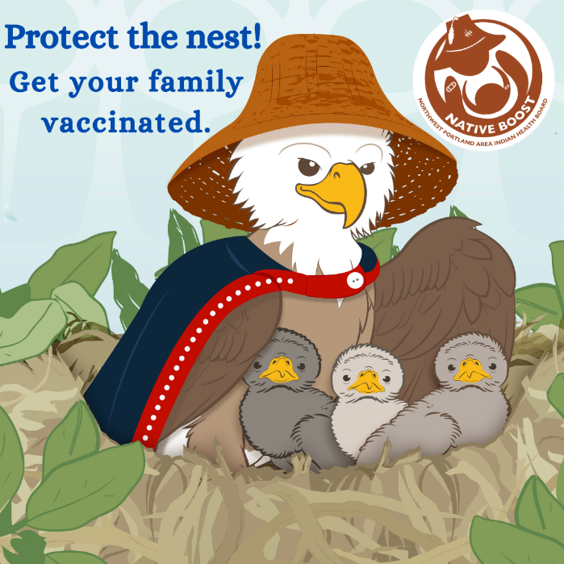

Proposed Text: As a parent, you understand the importance of protecting your precious eaglets. Shield them from illness by making sure that they are up to date on their vaccines. 🐦💪 Learn more at: www.NPAIHB.org/Native-Boost. #ProtectingTheNest #ProtectingOurFlock #NativeBoost
Edit on Canva:
https://www.canva.com/design/DAGiwCahmn8/oYkgwuDQHgrji7eOTHdSdw/view?utm_content=DAGiwCahmn8&utm_campaign=designshare&utm_medium=link&utm_source=publishsharelink&mode=preview

Image 3:
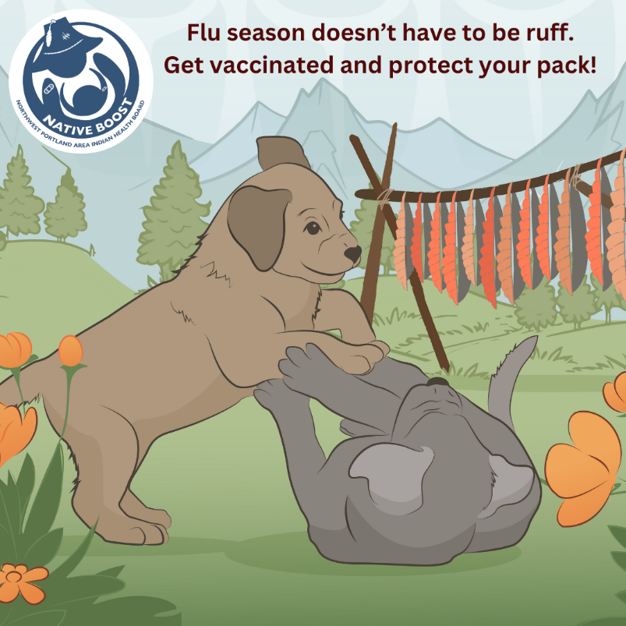
Proposed Text: Flu season doesn’t have to be ruff for your littles! 🐾 So, make sure you and your pups get vaccinated annually. Learn more at: www.NPAIHB.org/Native-Boost. #PawsibilitiesWithVaccines #NativeBoost
Edit on Canva:
https://www.canva.com/design/DAGiwLDx9vE/97B7hr7KP-ea71tEN4aUDg/view?utm_content=DAGiwLDx9vE&utm_campaign=designshare&utm_medium=link&utm_source=publishsharelink&mode=preview

Image 4:
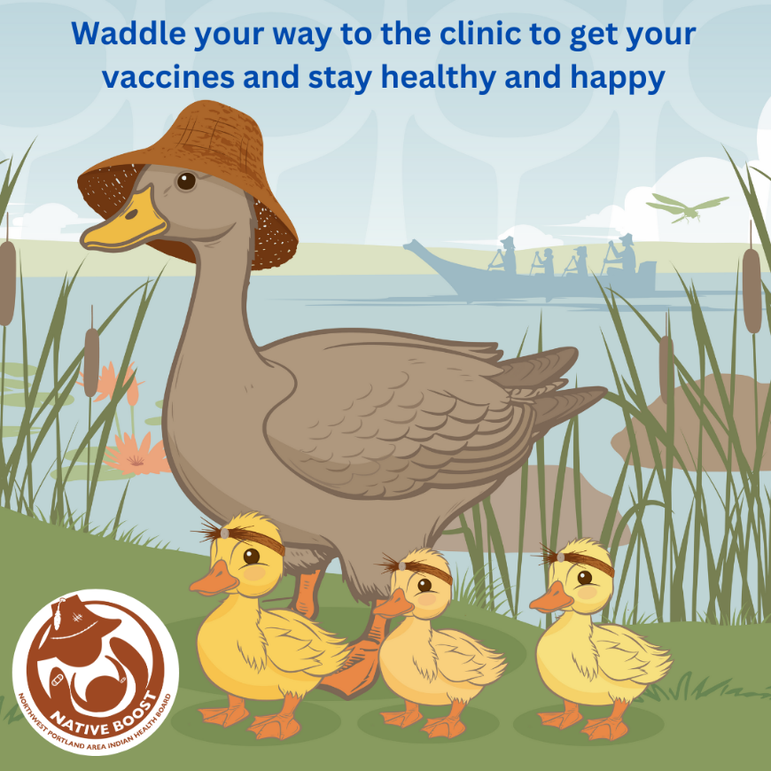

Proposed Text: Shield your little ducklings from serious illness! 🦆 Waddle your way to the clinic and learn what all the quack is about vaccines. Learn more at: www.NPAIHB.org/Native-Boost. #ProtectiveFeathers #HealthyFlock #NativeBoost
Edit on Canva:
https://www.canva.com/design/DAGiv9jDUfg/Q3H5NKOY1roQm0EcwvTM3w/view?utm_content=DAGiv9jDUfg&utm_campaign=designshare&utm_medium=link&utm_source=publishsharelink&mode=preview

Image 5:
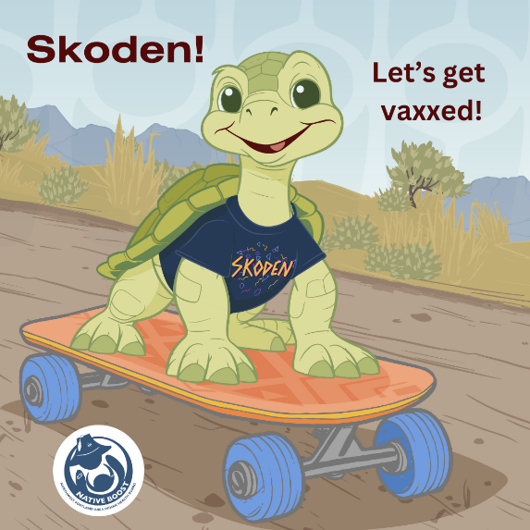

Proposed Text: Don’t let illness slow their roll! Ensure your little ones stay supercharged by getting them vaccinated. 🐢💨 🛼 For more info, visit: www.NPAIHB.org/Native-Boost. #ProtectingOurShells #NativeBoost
Edit on Canva:
https://www.canva.com/design/DAGiv-m2000/RRRVNkjy0hYHzXgurhhHzw/view?utm_content=DAGiv-m2000&utm_campaign=designshare&utm_medium=link&utm_source=publishsharelink&mode=preview

Image 6:
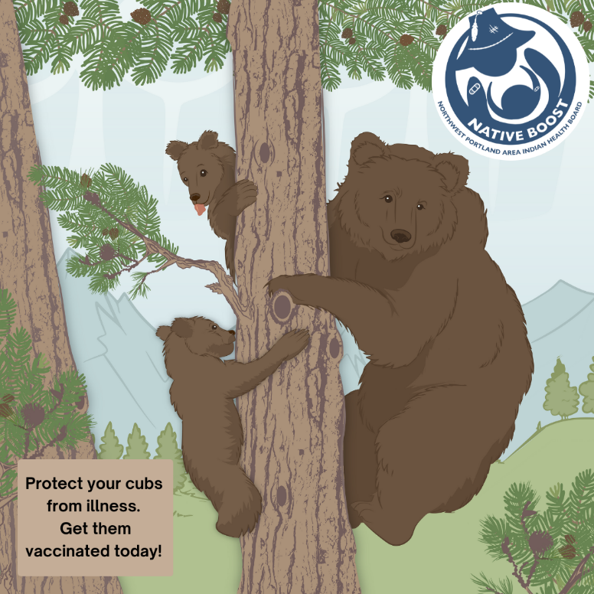

Proposed Text: Make flu season bearable for your cubs. 🐻 Protect your little ones with an annual flu vaccine so they don’t have to miss school or other fun events. Visit www.NPAIHB.org/Native-Boost to learn more. #FluFighters #ProtectingOurCubs #NativeBoost
Edit on Canva:
https://www.canva.com/design/DAGiv-S-0pM/jSaJbhcu_aAtxX6fcGTMiA/view?utm_content=DAGiv-S-0pM&utm_campaign=designshare&utm_medium=link&utm_source=publishsharelink&mode=preview

Image 7:
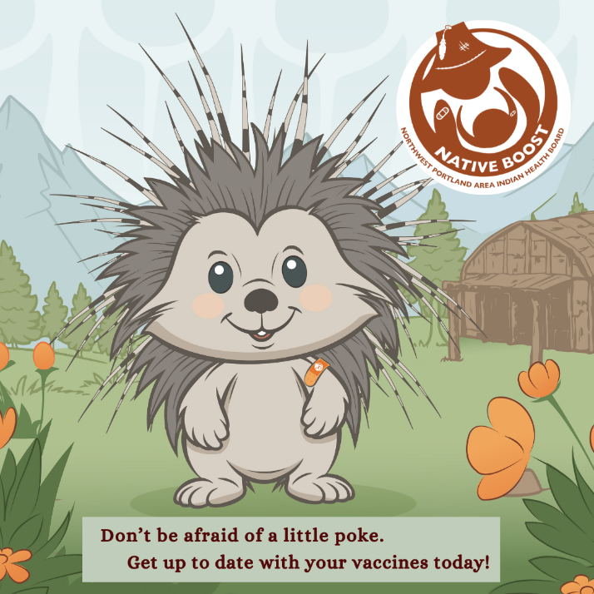

Proposed Text: This porcupine isn’t scared to get poked. 🦔 Get yourself and your child vaccinated to stay healthy and reduce sick days and last-minute trips to the clinic. Learn more by visiting: www.NPAIHB.org/Native-Boost. #VaccineWarrior #NativeBoost
Edit on Canva:
https://www.canva.com/design/DAGiwK5W2tg/EmDOCYbIq7GZEogBUbtIBA/view?utm_content=DAGiwK5W2tg&utm_campaign=designshare&utm_medium=link&utm_source=publishsharelink&mode=preview

Image 8:
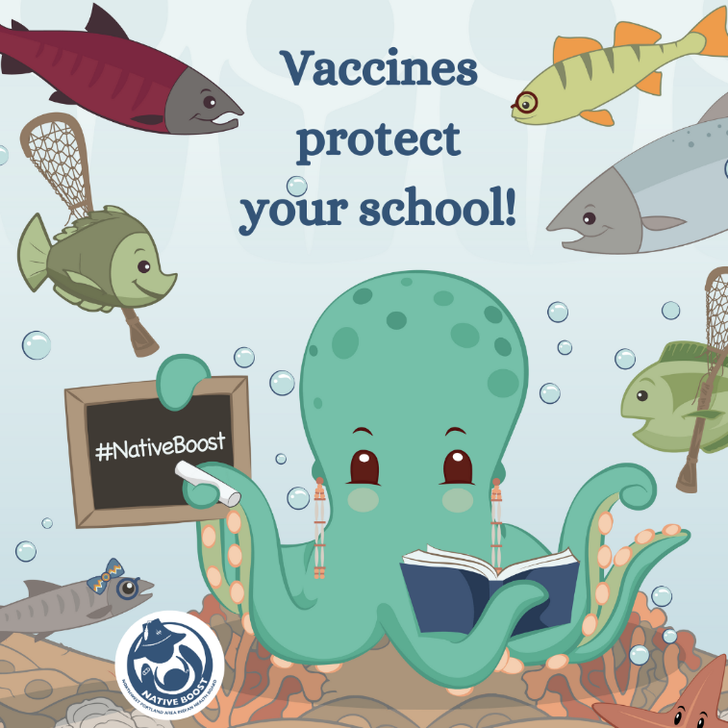

Proposed Text: When each little fish is vaccinated, the whole school is protected! 🐙 Let your little ones swim freely without the fear of serious illness. Learn more at: www.NPAIHB.org/Native-Boost. #HealthyLittleFish #NativeBoost
Edit on Canva:
https://www.canva.com/design/DAGiv1D0eNE/BwxYxVxgvxGRzdhUWe5GqA/view?utm_content=DAGiv1D0eNE&utm_campaign=designshare&utm_medium=link&utm_source=publishsharelink&mode=preview

Image 9:
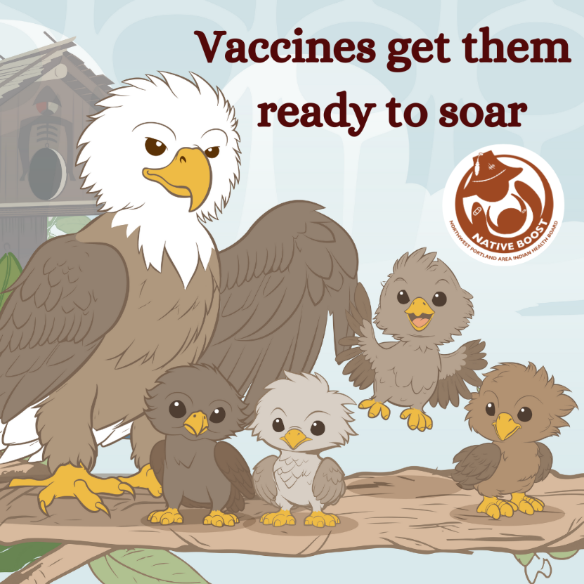

Proposed Text: Class is in session! 🎓 Are your kids ready to soar? Keep them healthy by making sure they are up to date on their vaccines. Learn more at www.NPAIHB.org/Native-Boost. #FlyLikeAnEagle #NativeBoost
Edit on Canva:
https://www.canva.com/design/DAGivxqn28Q/MBW-DPhHsbHcbgGkUpyuYQ/view?utm_content=DAGivxqn28Q&utm_campaign=designshare&utm_medium=link&utm_source=publishsharelink&mode=preview

Image 10:
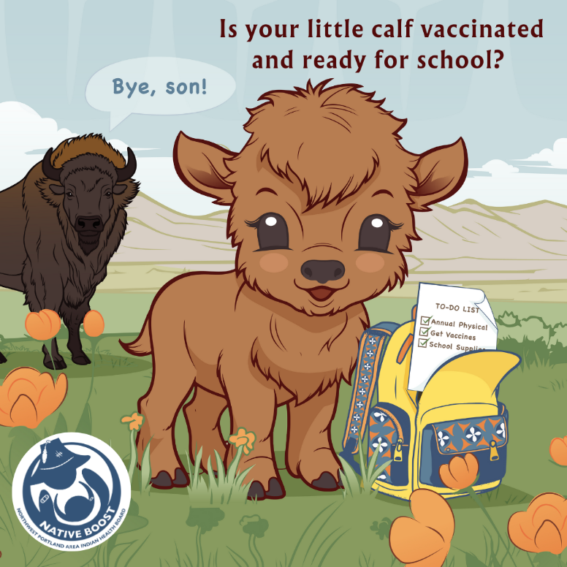

Proposed Text: Part of getting your calf ready for school includes checking that they are up to date on their vaccines! Give your little ones the best start! 📚 For more information on vaccinations for kids, visit: www.NPAIHB.org/Native-Boost #BackToSchoolProtection #NativeBoost
Edit on Canva:
https://www.canva.com/design/DAGiwCipqO8/1YF5J8Yyr79m9NmMJhjYWg/view?utm_content=DAGiwCipqO8&utm_campaign=designshare&utm_medium=link&utm_source=publishsharelink&mode=preview

