STI Awareness

Hashtags: #TakeControl #KnowYourStatus #GetTested #STDTesting #STITesting #SexualHealth #NativeHealth #IndigenousHealth #HIVTesting #HonoringOurFuture #ProtectYourself #PracticeSafeSex #TwoSpirit

Social Media Posts & Suggested Captions

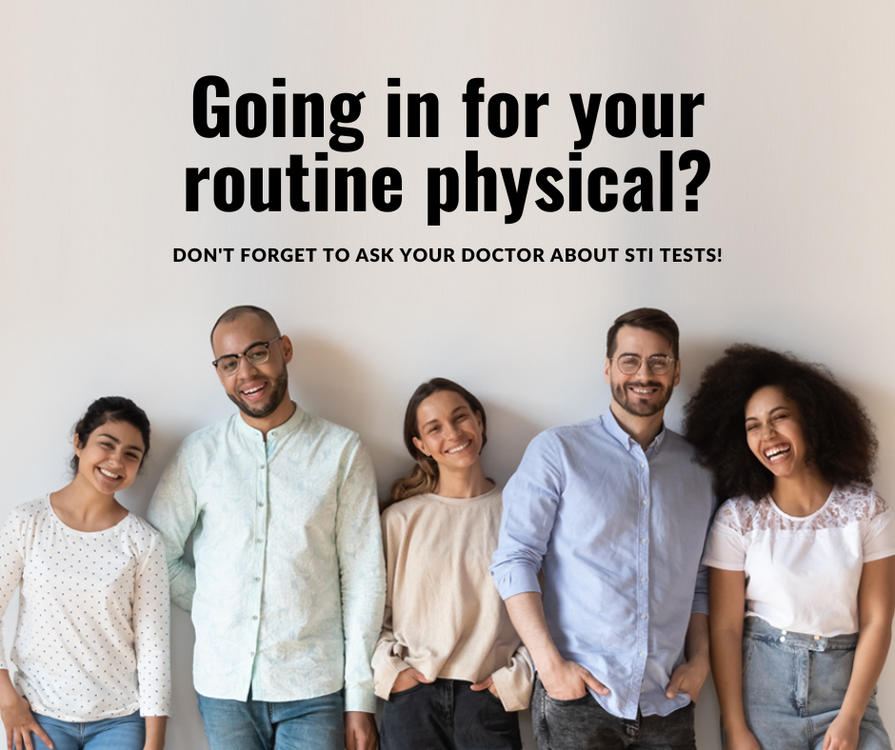  Click here to download | SUGGESTED CAPTION: Getting tested for STIs is one of the most important things you can do to protect your health.
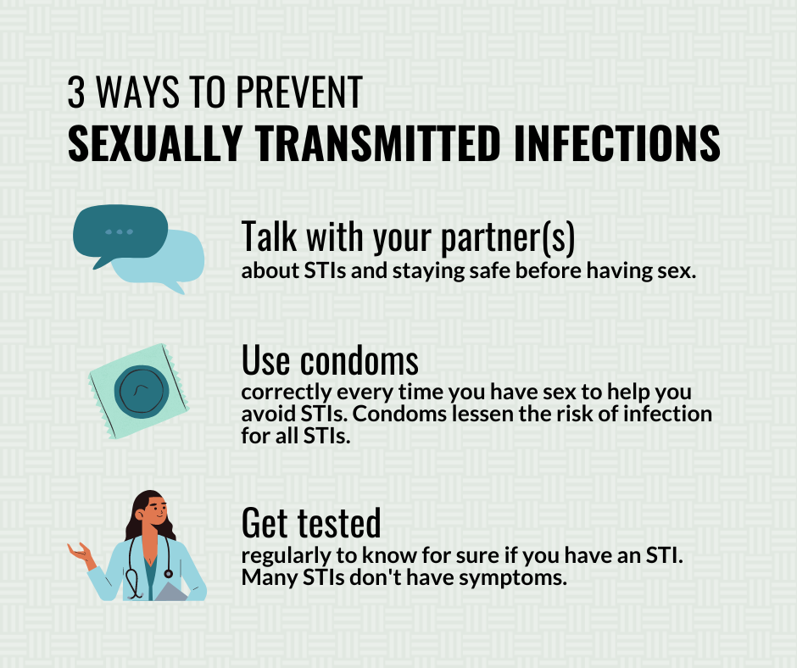  Click here to download | SUGGESTED CAPTION: Having open, honest conversations with your partner, using condoms, and getting tested are 3 ways to prevent STIs.
  Click here to download | SUGGESTED CAPTION: We are responsible for ourselves and each other. Protect yourself and your partner by using condoms correctly and consistently.
  Click here to download | SUGGESTED CAPTION: High-risk behaviors, such as unsafe sex, can lead to unplanned pregnancy and STIs. Draw upon your strengths and knowledge to overcome these risks by practicing safe sex every time.
  Click here to download | SUGGESTED CAPTION: Enjoy life. Be proactive. Use condoms.
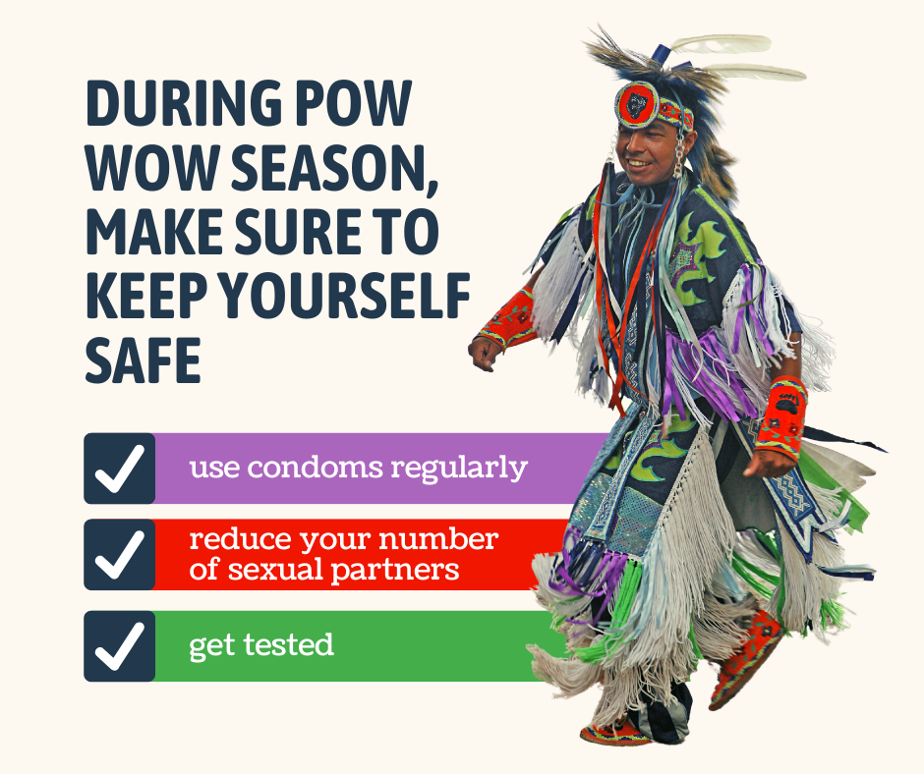  Click here to download | SUGGESTED CAPTION: Even in the thick of pow wow season, it’s important to keep yourself safe. Use condoms and practice safe sex.
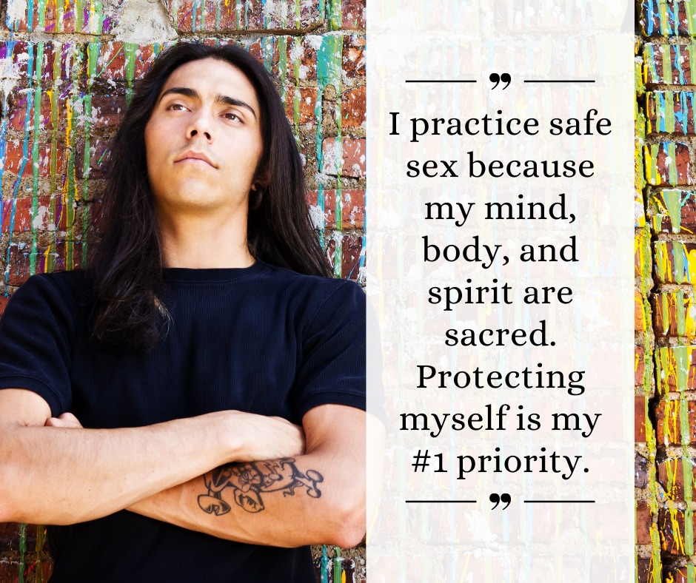  Click here to download | SUGGESTED CAPTION: Protecting yourself should be your #1 priority. It is important to get tested and use condoms correctly and consistently if you become sexually active.
  Click here to download | SUGGESTED CAPTION: Your body is a sacred gift from our Creator. Respect and honor yourself by practicing safe sex.
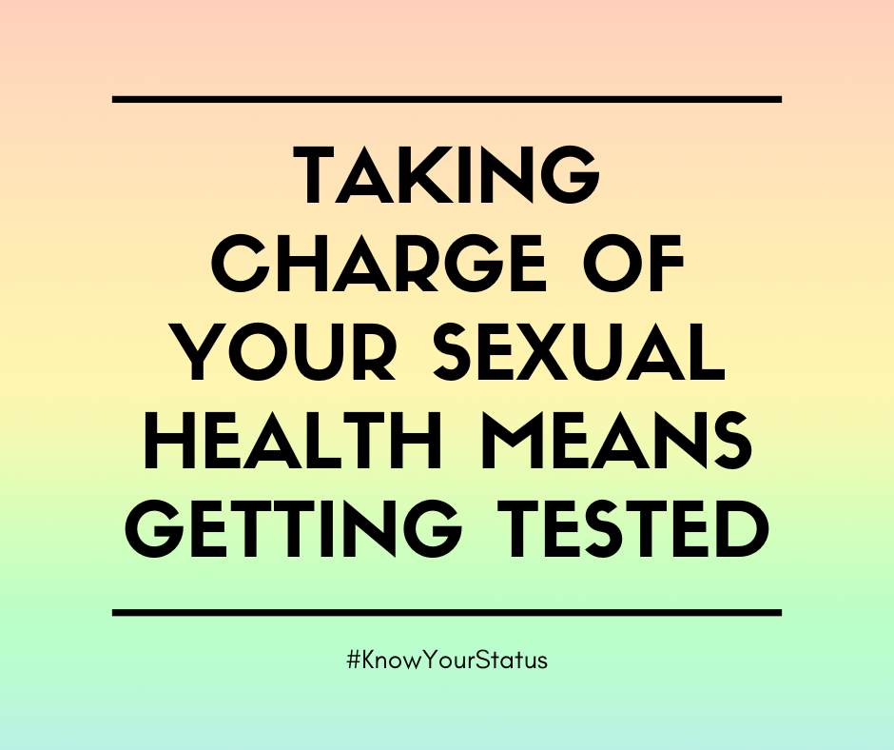  Click here to download | SUGGESTED CAPTION: Taking charge of your sexual health means getting tested and taking medication when necessary. Order your free, confidential, at-home test kit: iwantthekit.org
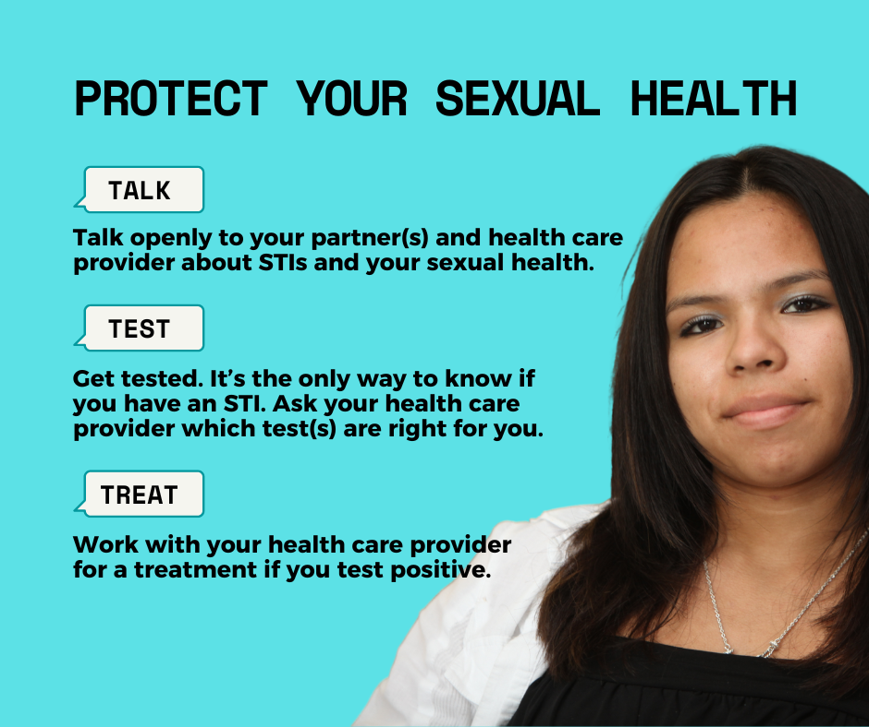  Click here to download | SUGGESTED CAPTION: It’s necessary to protect your sexual health and take preventative care. Talk to your partner and your healthcare provider, get tested for sexually transmitted infections (STIs), seek treatment if necessary.  ➡️ Order your free, confidential, at-home STI & HIV test kit: iwantthekit.org
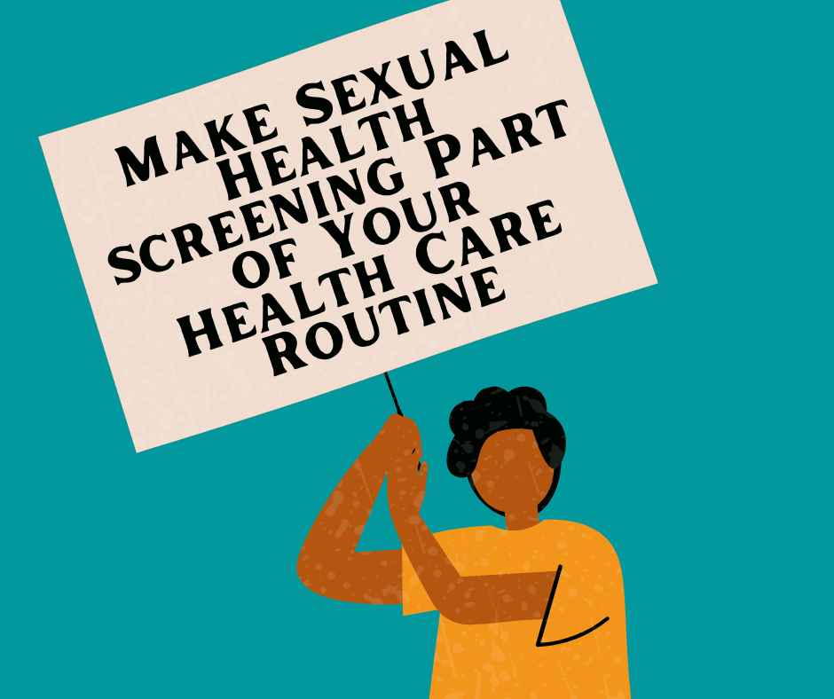  Click here to download | SUGGESTED CAPTION: Preventive health services (such as the HPV vaccine and STI testing) can protect and improve your sexual health, and even save lives. Yet, over half of us are not getting these highly recommended services, which include vaccines, screenings, contraceptives, and counseling. Both men and women should request these services during their yearly physical.  You can also order a free, confidential, at-home HIV/STI test kit by visiting https://iwantthekit.org/
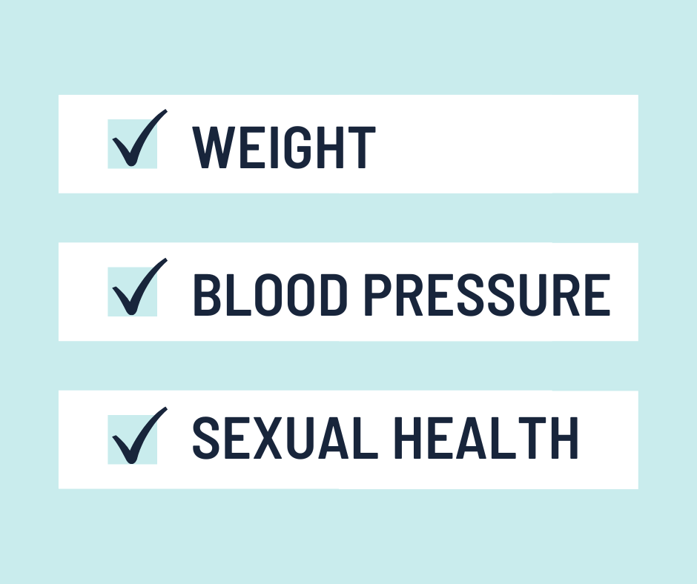  Click here to download | SUGGESTED CAPTION: Be sure to request regular sexual health check-ups. Keeping on top of your sexual health should be part of your health care routine every year, just like blood pressure checks. If any problems or symptoms develop in between visits — or you think you might be at risk — make an appointment right away.
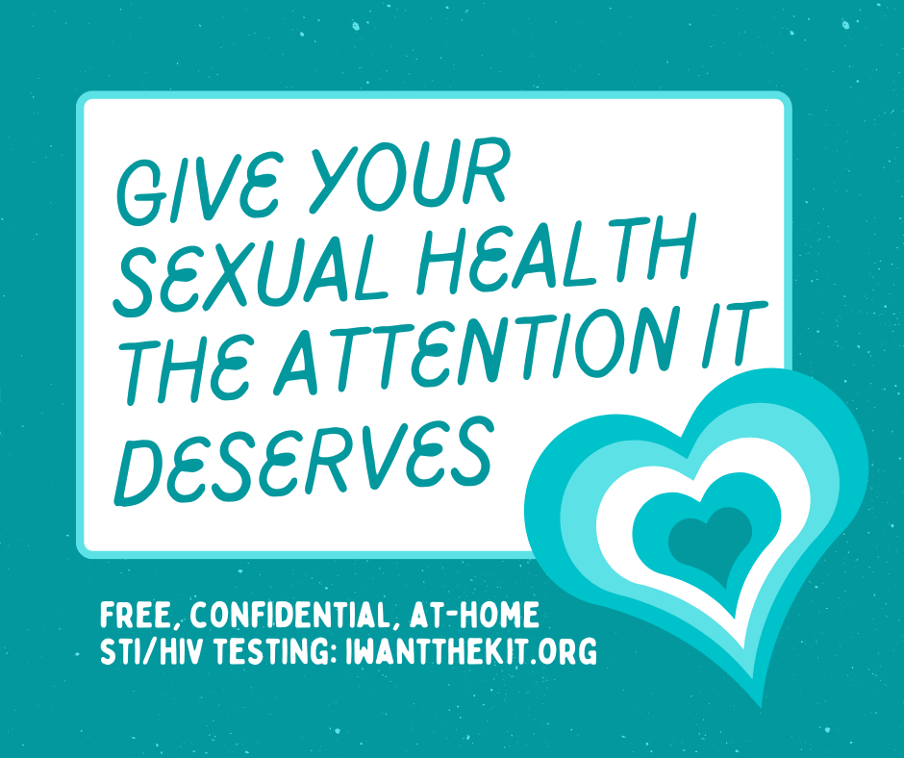  Click here to download | SUGGESTED CAPTION: It’s time to give your sexual health the attention it deserves! Order your free, confidential, at-home STI/HIV test kit: iwantthekit.org
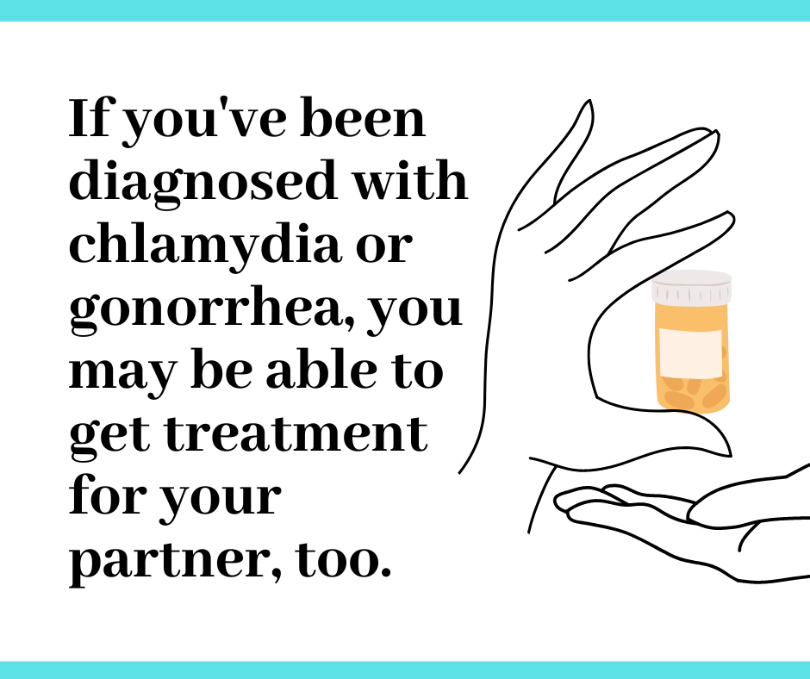  Click here to download | SUGGESTED CAPTION: Expedited Partner Therapy (EPT) can help reduce the transmission of chlamydia or gonorrhea. If you’ve been diagnosed with chlamydia or gonorrhea, the first step is to get treatment for yourself.  You may also be able to get treatment for your partner. It’s important for your partner to get treated quickly to protect them from passing the infection back to you or to someone else in the future. Ask your healthcare provider about EPT.
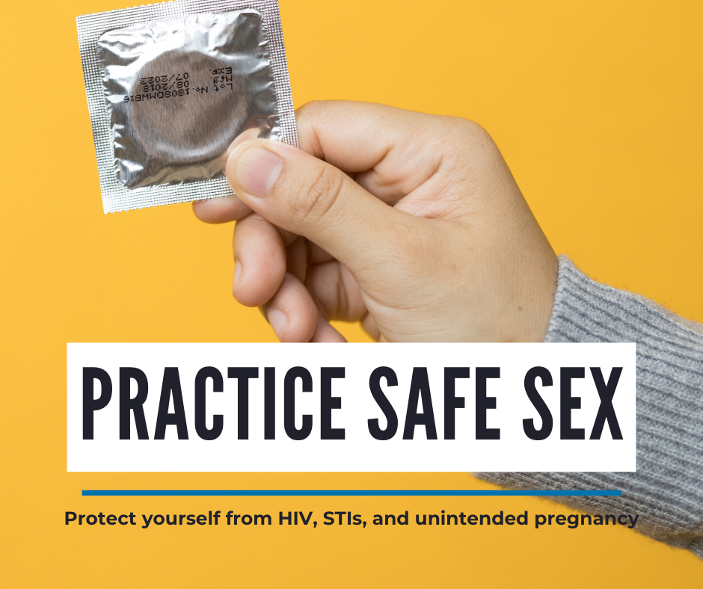  Click here to download | SUGGESTED CAPTION: Protect yourself from HIV, STIs, and unintended pregnancy by using a condom every time you have sex. Talk to your doctor about correct condom usage and additional birth control options.
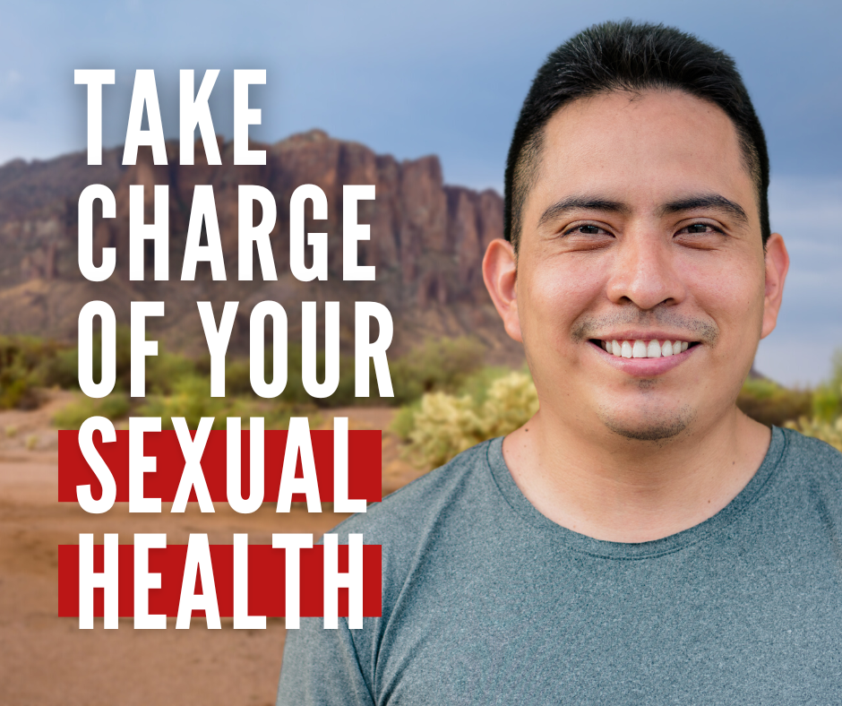  Click here to download | SUGGESTED CAPTION: Protect your health and wellbeing by making sexual health part of your health care routine. Start by ordering your free, confidential, at-home HIV/STI test kit: https://iwantthekit.org/
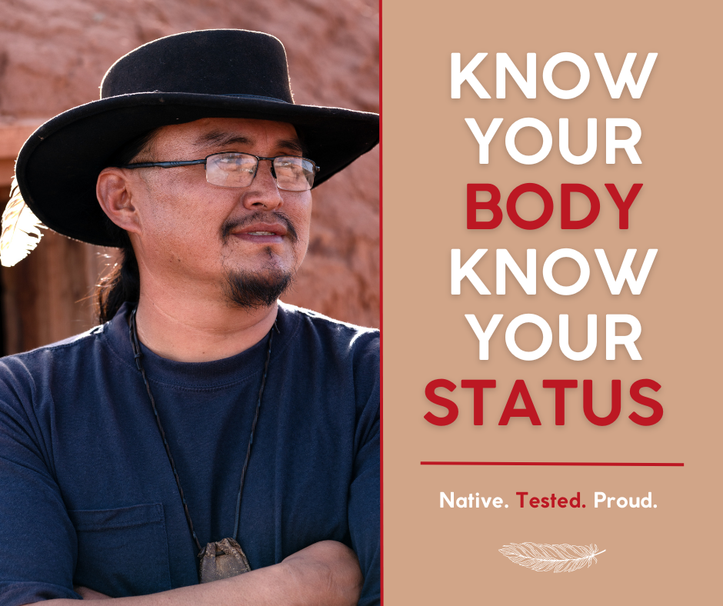  Click here to download | SUGGESTED CAPTION: Know your body. Know your status. Order your free, at-home HIV/STI test kit: https://iwantthekit.org/
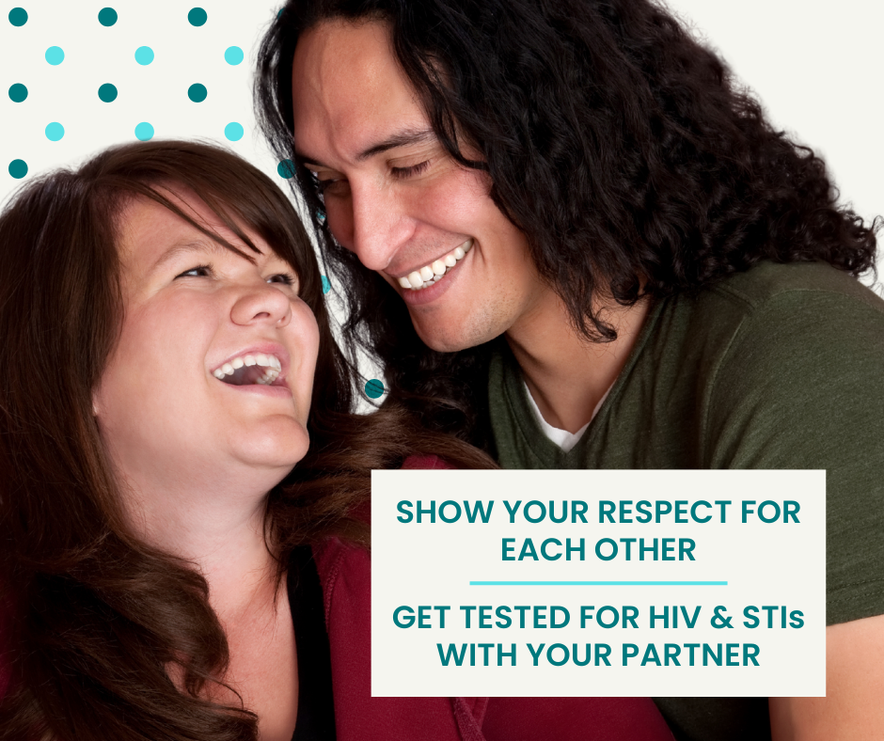  Click here to download | SUGGESTED CAPTION: Both you AND your partner should be tested for sexually transmitted infections (STIs).  ➡️ Order your free, confidential, at-home STI & HIV test kit: iwantthekit.org
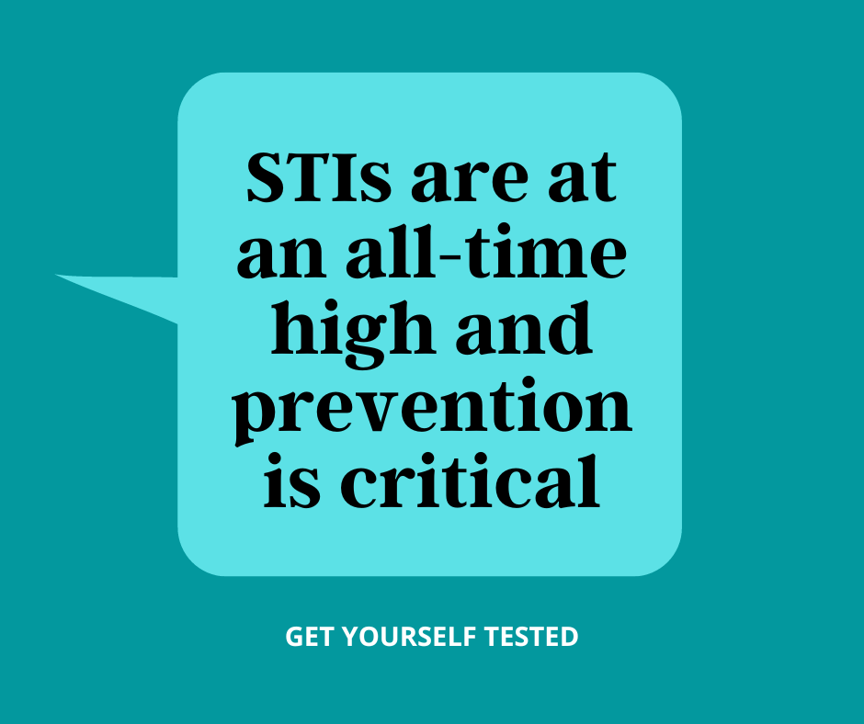  Click here to download | SUGGESTED CAPTION: Sexually Transmitted Infections (STIs) are at an all-time high and prevention is critical. The good news: there are many ways to get STI care! I Want The Kit provides free, confidential, at-home STI/HIV testing.  ➡️ Order your test kit here: iwantthekit.org
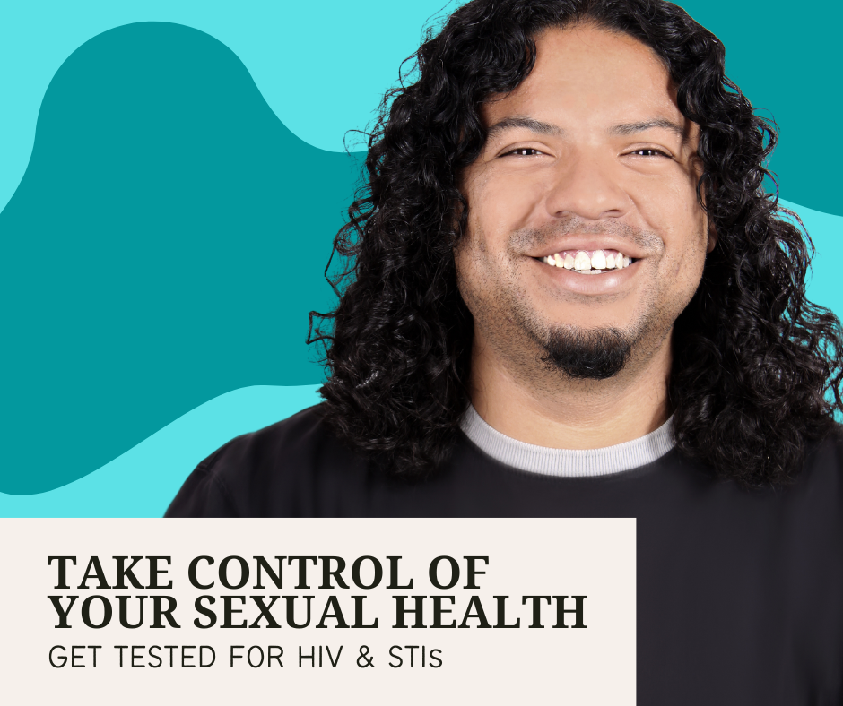  Click here to download | SUGGESTED CAPTION: Order your free, confidential, at-home STI & HIV test kit: iwantthekit.org
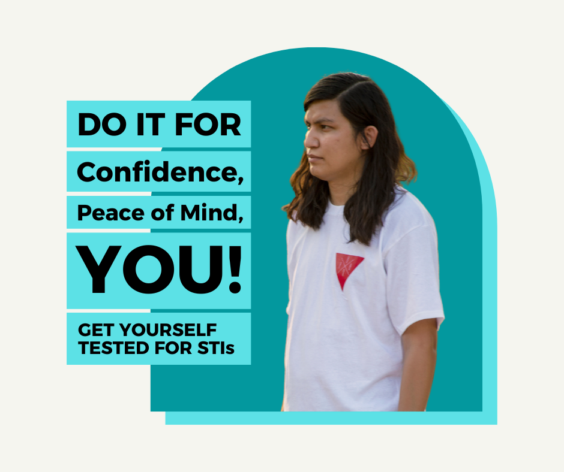  Click here to download | SUGGESTED CAPTION: Many Sexually Transmitted Infections (STIs) have no symptoms. The only way to know if you have an STI is to get tested.  ➡️ Order your free, confidential, at-home STI & HIV test kit: iwantthekit.org
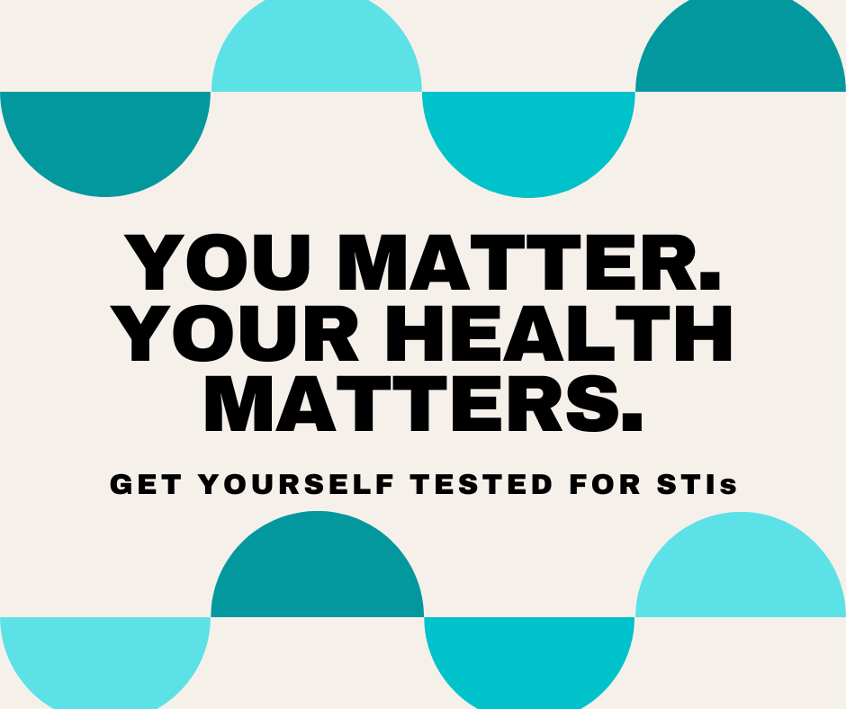  Click here to download | SUGGESTED CAPTION: Take control of your sexual health by getting tested for sexually transmitted infections (STIs).  ➡️ Order your free, confidential, at-home STI & HIV test kit: iwantthekit.org

DOWNLOAD ALL STI AWARENESS GRAPHICS HERE

