Clear
Sick Day Check-in for Diabetes with COVID-19
- Symptoms/ how doing overall compared to the day before
  - Fever spikes
    - Temp ranges if has thermometer
  - Trouble breathing – ability to ambulate (SOB), blue fingernails or lips, cold skin, somnolence
    - Pulse Ox readings if available
    - New onset tachypnea (rapid breathing)– consider DKA
  - Chest pain
  - Fatigue – ability for self-care
  - Appetite
    - Able to eat or not
      - Unusual increase in hunger – consider DKA
    - Fluid intake – able to maintain or not*
      - Increased thirst – consider DKA or severe hyperglycemia
      - Orthostatic symptoms
  - Urine output
    - Reduced – dehydration/renal impairment
    - Increased – consider DKA or severe hyperglycemia
  - Confusion, ability to wake up
  - GI symptoms if present –
    - diarrhea worse or better
    - new onset nausea/vomiting – consider DKA
  - New symptoms – e.g. neurologic symptoms/stroke
- What medications they are currently taking/able to take
  - Any OTC meds or herbs, etc.
    - Acetaminophen preferred over NSAID for fever to reduce risk of acute kidney injury from NSAIDs – ensure not exceeding 3-4 gram/day max
  - Diabetes Meds**
    - Current meds – what have they been able to take, what missed
    - Any adjustments made by patient/caregiver
  - Other meds – on med list
    - BP meds, etc.
- Blood sugar issues
  - Monitoring at least every 4 hours (some situations benefit from every 2 hours/CGM)
  - Low BG symptoms or results –
    - How frequent/ how severe
    - Ability to Treat low blood sugar – PWD or caregiver ideally needs to know how to treat low BG before it happens – ensure appropriate treatment (rapid glucose vs other such as peanut butter, sandwich, etc.) -
      - Rapid glucose – ensure have access to some source of rapid glucose
        - If low (blood sugar below 70 mg/dl or target range), eat 15 grams of simple carbs that are easy to digest like glucose tabs, honey, jam, Jell-O, hard candy, popsicles, juice or regular soda, and re-check BG in 15 minutes to make sure levels are rising.
      - Glucagon rescue – sick day use
        - Kit
        - Pre-filled syringe
        - Nasal
    - Adjust meds as appropriate**
    - If no hypoglycemia yet but at risk (sulfonylurea med or insulin) – review how to treat, ensure has rapid glucose source and/or glucagon
  - BGs over 250
    - How frequent/how severe
    - Signs/symptoms of dehydration
    - Signs/symptoms of DKA (polyurea, polydipsia, hunger/nausea, rapid breathing)
    - Adjust meds as appropriate** or triage to ED/hospital
*Fluids – Sick day meals & fluids - maintain hydration/avoid hypoglycemia
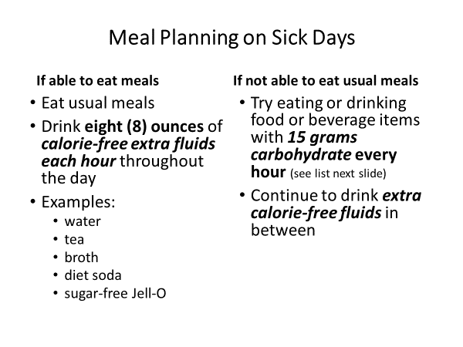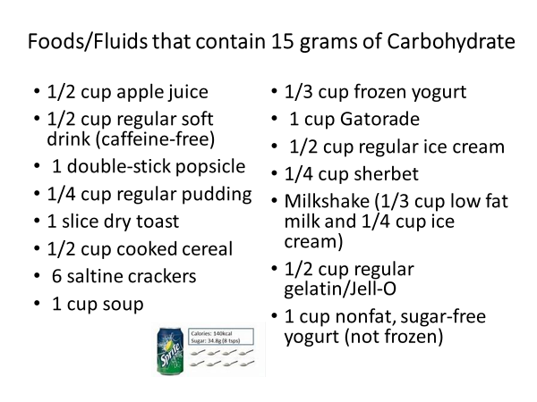
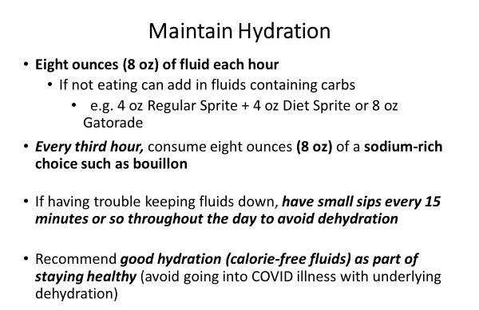

**Diabetes Meds
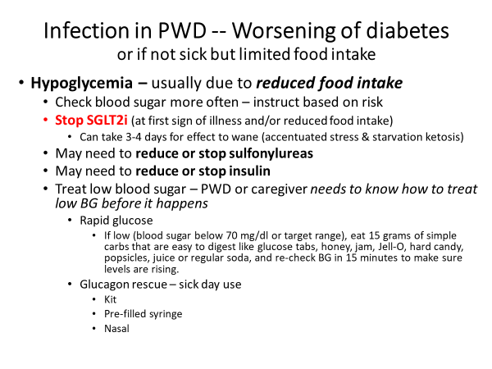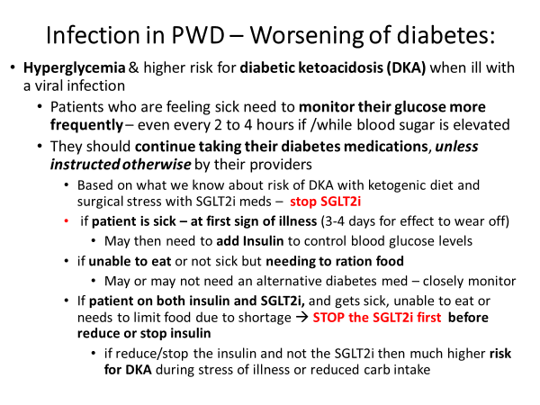
SGLT2 inhibitor medications increase formation of ketones and can exacerbate the ketones from low carb intake and/or stress / infection resulting in Diabetic Ketoacidosis (DKA) (often “euglycemic DKA – meaning DKA despite BG under 300)
- The patient may or may not need to increase /add insulin to control blood glucose levels after SGLT2 inhibitor is held – requires close monitoring – see sick day insulin below
Preventing severe hyperglycemia / DKA
- If reduced intake, dehydration, N/V/D – stop Metformin, GLP1-RA
- May need to add “sick day” insulin
  - If patient is current insulin user
    - Adjust Basal Insulin & add “correction insulin” – see below
  - Patients new to insulin
    - Instructing patients new to insulin – consider
      - Use pens, if possible, for simplicity
      - Tele-video visit to instruct and help monitor/adjust if possible
      - Phone call to instruct & monitor/adjust
        - if possible, use you-tube (several available) as visual aid
      - Car visit --- instructions provided from outside with patient/caregiver in car (window up – use phone if possible) – then monitor by phone/tele-visit
      - Brainstorm and share ideas
    - Calculating Insulin doses in patients new to insulin - Basal Insulin & Correction Insulin
      - Calculate starting doses of insulin
        - 0.5-0.7u/kg = Starting Total Daily Dose or
        - 0.25u x weight in pounds = Starting Total Daily Dose
        - E.g. 100 kg patient = 50 - 70 units or 220 pounds = 55 units
      - Start with ½ of total daily dose as Basal Insulin - e.g. 25-35 units insulin glargine
        - If patient sick & has increased insulin resistance may need to rapidly increase dose - need to monitor & adjust based on FBS –
        - Call patient daily or algorithm for patient/caregiver
        - Start with 20% increase if BG in 200s, 30% increase if BGs in 300s
        - May need to double dose or even more if severe insulin resistance
        - With insulin glargine – split dose to BID if > 50u per injection
        - Can use NPH BID (some are doing q8hour during COVID19)
        - 50% AM and 50% PM if not eating (e.g. start at 15u BID for 100 kg patient) and adjust as needed
        - Can use 50% AM & 50% PM or 2/3 AM and 1/3 PM if eating
      - Bolus (mealtime) Insulin - if eating meals add 10-20% of starting dose as rapid-acting insulin with each meal – hold if not eating
        - e.g. 5-10 units before each meal for 50u starting total dose for 100 kg patient
        - More refined methods can be used if needed during the often-prolonged recovery stage of COVID19 illness***
      - Correction Insulin - Intended to decrease BG levels to target range – based on patient’s “sensitivity or correction factor” - can be used to:
        - add more insulin to a mealtime bolus to correct for a high premeal blood glucose (e.g. 5u if BG 80-140, 6u (5u+1u) if 141-170, 7u(5+2u) if 171-200, etc.)
        - Used alone to correct a high blood glucose outside of mealtime or if NPO
        - The right correction dose will return the BG to within 30 mg/dl of the target blood glucose about 3-4 hours after the dose is injected
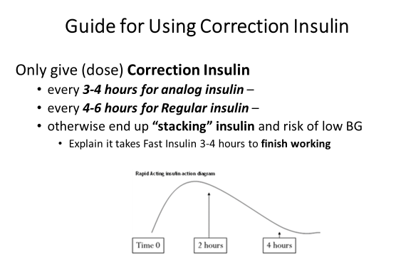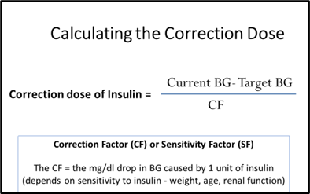
CF based on patient weight
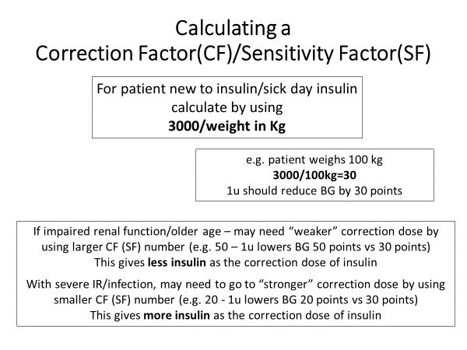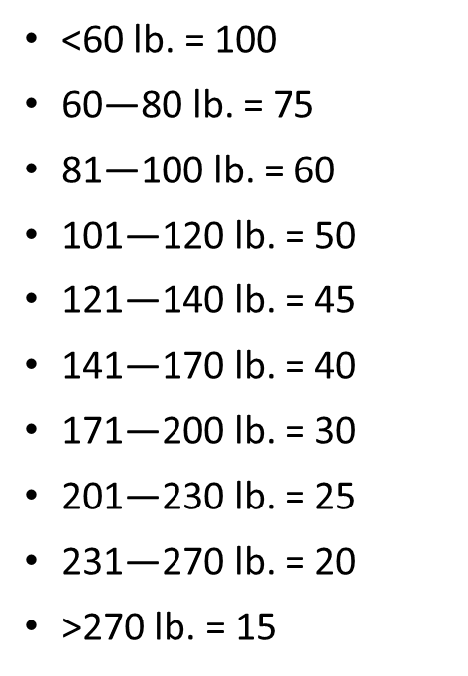
        - During illness aim for blood glucose in 110-180 range
          - if high risk of low BG, aim for 140-180 range
          - e.g. use target BG of 140 for 110-180 range
        - The Correction dose can be calculated by using the formula or the patient can use a sliding scale based on their sensitivity factor (correction factor)
          - Example of Correction dose calculation for CF 30
          - [current BG-target BG/CF] – e.g. Current BG is 350 and target is ~140
          - 350-140/30 = 210/30 = 7u correction dose of rapid acting insulin to bring BG down 210 points
            - To strengthen use smaller CF: e.g. 210/25= 8u; 210/20 = 10.5u; 210/15 = 14u … to reduce BG 210 points
          - Or Can give patient a correction scale: e.g. for BG 180-210 1u; BG 211-240 2u; BG 241-270 3u, 271-300 4u, BG 301-330 5u, etc.
            - See cheat sheet for different scales based on different CF values


